Mock Test 3

- If the areas of the circle and the rectangle are equal and the area of the shaded region is 10 cm², find the area of the rectangle.
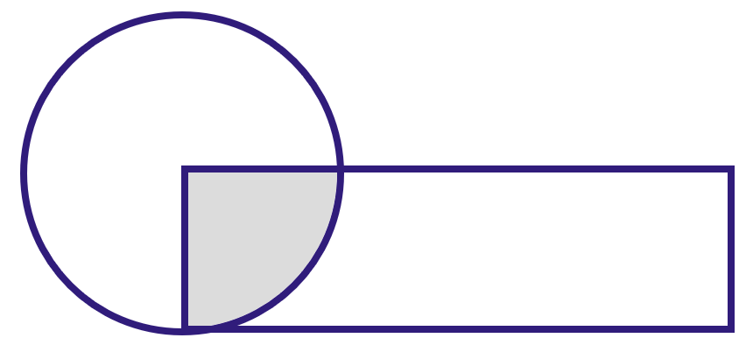
A) 40 cm²
B) 30 cm²
C) 60 cm²
D) $75{cm}^{2}$
Difficulty level: H
Lesson: Shaded Areas
- If the side of the square is 4 cm, find the area of the shaded region.
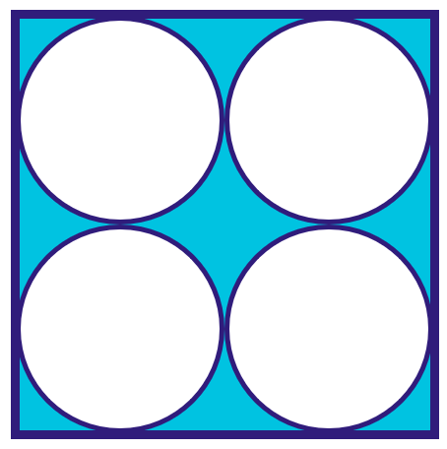
A) $16-4π$ cm²
B) $8-π$ cm²
C) $16-π$ cm²
D) $12π$ cm²
Difficulty level: H
Lesson: Shaded Areas
- Compare:
A | B
The value of $h$ if: $3(3)^{h}=81$ | The value of $m$ if: $8×3m=96$
A) A is greater
B) B is greater
C) Equal
D) Not enough information
Difficulty level: M
Lesson: Exponents
- If $0<A<B$ and $B>1$, which of the following is the largest number?
A) $\frac{A}{B}$
B) $\frac{B}{A}$
C) ${\left(\frac{A}{B}\right)}^{2}$
D) ${\left(\frac{B}{A}\right)}^{2}$
Difficulty level: H
Lesson: Exponents
- Evaluate: $\frac{2^{5}\sqrt{3}+2^{3}\sqrt{3}}{5\sqrt{3}}$
A) 2
B) 4
C) 8
D) 10
Difficulty level: M
Lesson: Exponents
- If the triangle is equilateral, find $x$.
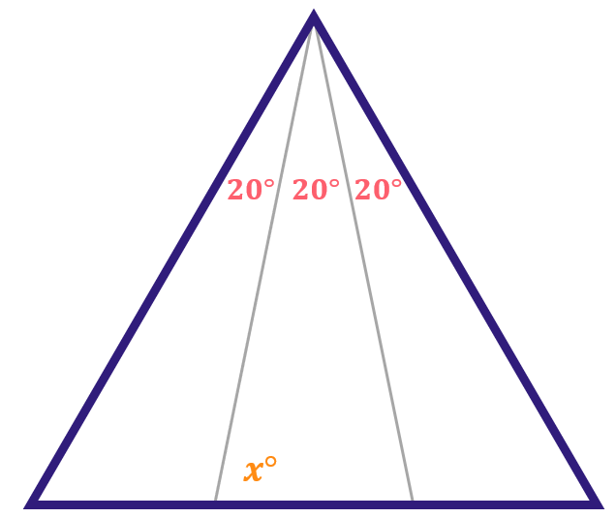
A) ${80}^{∘}$
B) ${65}^{∘}$
C) ${55}^{∘}$
D) ${50}^{∘}$
Difficulty level: M
Lesson: Triangles
- 3 tangent circles each with radius equal to 1 cm are making the opposite shape. What is the combined circumference?
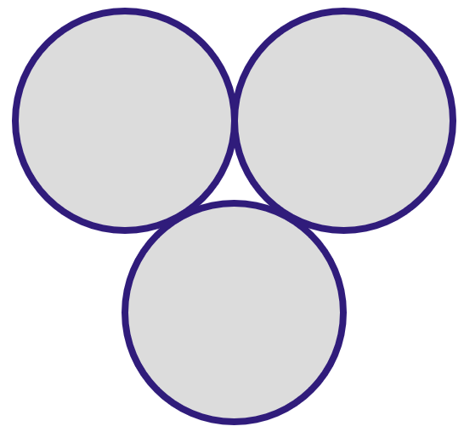
A) 6
B) $5π$
C) $6π$
D) $8π$
Difficulty level: M
Lesson: Circles
- The ratio of the diameters of two circles is 240 cm to 200 cm. By how much is the bigger circle's area greater than the smaller circle's area?
A) $22\%$
B) $44\%$
C) $30\%$
D) $20\%$
Difficulty level: H
Lesson: Circles
- A person wants to convert 7,777 Saudi riyals into Bahraini dinars. The exchange rate is 10 Saudi riyals for 1 Bahraini dinar. If the bank only gives 20-dinar notes, how many 20-dinar notes will the person receive?
A) 30
B) 35
C) 38
D) 40
Difficulty level: H
Lesson: Numbers & Order of Operations
- Khaled has spent 38 riyals. If one pie costs 5 riyals and one drink costs 7 riyals, how many drinks did he buy?
A) 3 Drinks
B) 4 Drinks
C) 5 Drinks
D) 6 Drinks
Difficulty level: M
Lesson: Numbers & Order of Operations
- A box contains 30 apples: 18 are green and 12 are red. There are 20 good apples in total. If there are $8$ good red apples, then how many green apples are spoiled?
A) 5
B) 6
C) 7
D) 8
Difficulty level: M
Lesson: Numbers & Order of Operations
- Compare:
A | B
$$-17\left(\frac{29}{-15}\right)$$ | $$-18\left(\frac{-36}{-25}\right)$$
A) A is greater
B) B is greater
C) Equal
D) Not enough information
Difficulty level: H
Lesson: Numbers & Order of Operations
- What is the next number in the sequence: $15, 17, 20, 24, …?$
A) 27
B) 29
C) 30
D) 31
Difficulty level: L
Lesson: Numbers & Order of Operations
- A rectangle with a perimeter of 28 cm is divided into 5 equal rectangles as shown. Find the area of one rectangle.
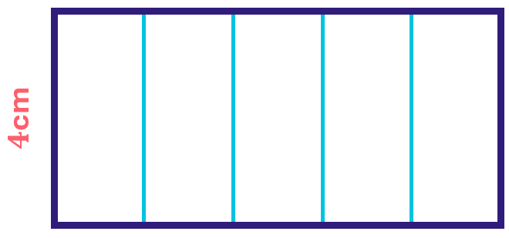
A) 10 cm²
B) 8 cm²
C) 12 cm²
D) 6 cm²
Difficulty level: M
Lesson: Areas, Perimeters & Volumes
- Evaluate: $\frac{700}{10}+\frac{7}{100}+\frac{7}{1000}+\frac{1}{100}$
A) 7.777
B) 70.087
C) 70.077
D) 70.078
Difficulty level: L
Lesson: Decimals
- Calculate: $0.314×1.86$
A) 0.36547
B) 0.3546
C) 0.58404
D) 0.57645
Difficulty level: M
Lesson: Decimals
- ABCD is a square with a side length of 4 cm. What is the area of trapezoid BCFE?
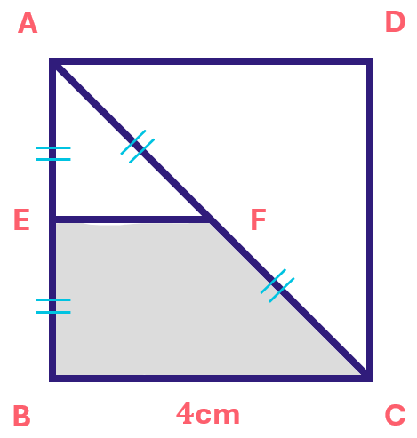
A) 4 cm²
B) 8 cm²
C) 12 cm²
D) 6 cm²
Difficulty level: H
Lesson: Polygons & Quadrilaterals
- Five times a number is equal to $20\%$ of 150. What is that number?
A) 10
B) 8
C) 6
D) 9
Difficulty level: L
Lesson: Ratios & Percentages
- A man buys an item for 12000 riyals and sells it for 14000 riyals, then he buys it again for 16000 riyals and sells it for 18000 riyals. Which of the following is correct?
A) A loss of 4000 riyals
B) A profit of 4000 riyals
C) A loss of 6000 riyals
D) A profit of 6000 riyals
Difficulty level: M
Lesson: Ratios & Percentages
- If $\frac{1}{6}f=10\%$ of $1000$, find $f.$
A) 900
B) 400
C) 600
D) 180
Difficulty level: L
Lesson: Ratios & Percentages
- Mohammed prints $48$ pages in $45$ minutes. How many pages does he print in an hour?
A) 55
B) 60
C) 64
D) 70
Difficulty level: M
Lesson: Proportions
- Find $x$, where $m∖∖n$.
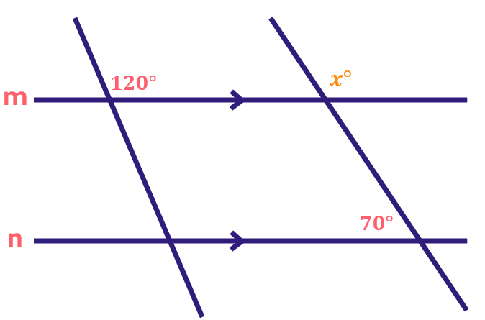
A) 110
B) 100
C) 70
D) 120
Difficulty level: M
Lesson: Angles
- Find the measure of $x+y$.
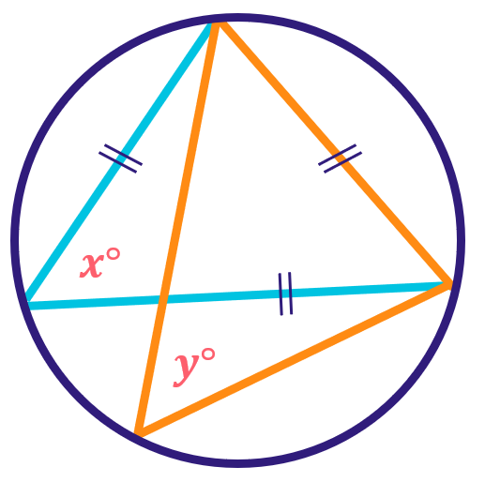
A) ${80}^{∘}$
B) ${100}^{∘}$
C) ${150}^{∘}$
D) ${120}^{∘}$
Difficulty level: M
Lesson: Angles
- Find $x$ where $2x-1=4x-3(2-x)$.
A) 1
B) 2
C) 8
D) 7
Difficulty level: M
Lesson: Algebraic Expressions, Equations & Inequalities
- A number plus three times itself, increased by 5, is equal to five times the original number. What is the number?
A) 5
B) 9
C) 2
D) 4
Difficulty level: M
Lesson: Algebraic Expressions, Equations & Inequalities
- Compare:
A | B
$${14}^{2}$$ | $$2×3^{4}+5$$
A) A is greater
B) B is greater
C) Equal
D) Not enough info
Difficulty level: M
Lesson: Algebraic Expressions, Equations & Inequalities
- If $ax^{2}-by^{2}=ay^{2}-bx^{2}$ and $a+b≠0$, then $x^{2}-y^{2}=$
A) 2
B) 1
C) 0
D) -1
Difficulty level: H
Lesson: Algebraic Expressions, Equations & Inequalities
- Solve $\frac{1+\frac{1}{x}}{x-\frac{1}{x}}$
A) $\frac{1}{1+x}$
B) $\frac{1}{1-x}$
C) $\frac{1}{x-1}$
D) $\frac{1}{x}$
Difficulty level: H
Lesson: Algebraic Expressions, Equations & Inequalities
- $A=2B, B=2C, C=2D, D=2$. Compare:
A | B
$$\frac{B+C}{9}$$ | $$\frac{A+D}{6}$$
A) A is greater
B) B is greater
C) Equal
D) Not enough info
Difficulty level: H
Lesson: Algebraic Expressions, Equations & Inequalities
- The graph shows the sales of a clothing store. Which month had the highest total sales?
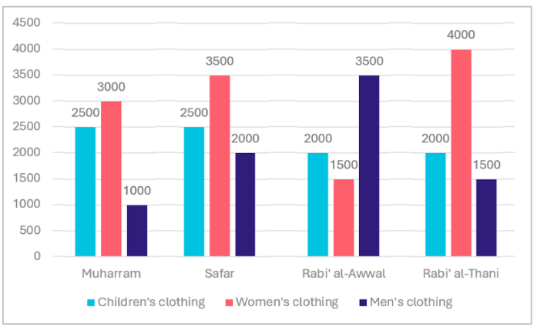
A) Rabi’ al-Thani
B) Rabi’ al-Awwal
C) Safar
D) Muharram
Difficulty level: L
Lesson: Data Analysis
- There are 300 students represented in the opposite shape. How many students were absent?
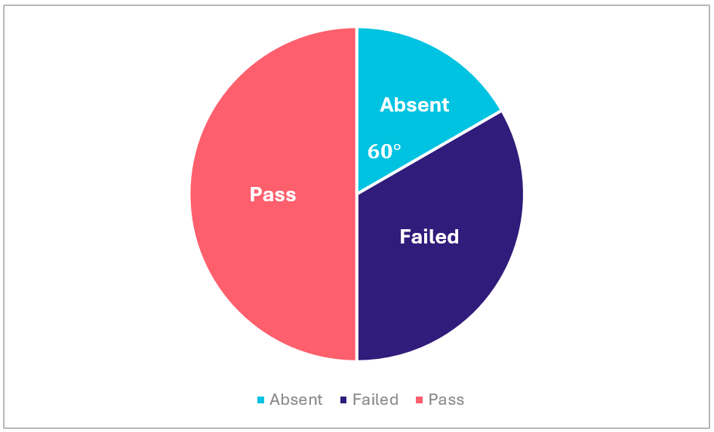
A) 100
B) 80
C) $40$
D) 50
Difficulty level: L
Lesson: Data Analysis
- Based on the figure below, what was the profit in September?
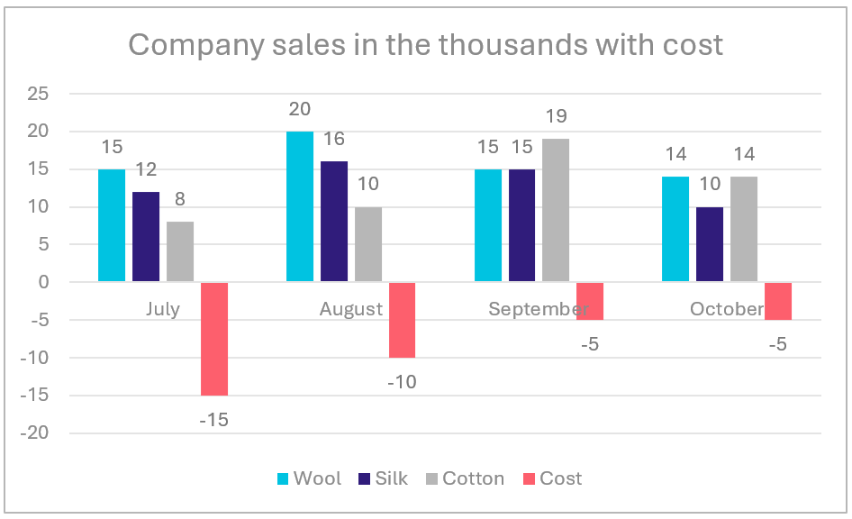
A) 50000
B) 44000
C) 35000
D) 48000
Difficulty level: M
Lesson: Data Analysis
- The graph shows the percentages of cars made in different countries. Which country is the largest producer of cars?
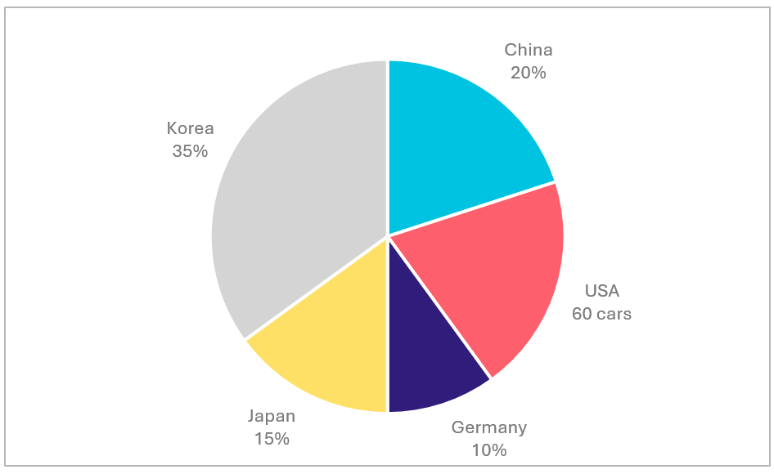
A) Korea
B) China
C) USA
D) Japan
Difficulty level: L
Lesson: Data Analysis
- The table shows data of different schools. What percentage of the total classrooms are in Al-Nour School approximately?
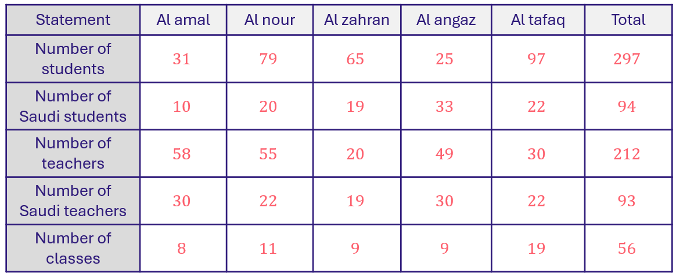
A) $19.5\%$
B) $25.2\%$
C) $30.4\%$
D) $40.1\%$
Difficulty level: M
Lesson: Data Analysis
- Compare:
A | B
$$\frac{-4}{9}$$ | $$\frac{-9}{4}$$
A) A is greater
B) B is greater
C) Equal
D) Not enough information
Difficulty level: L
Lesson: Fractions
- Evaluate $\frac{1}{1+\frac{1}{1+\frac{1}{4}}}=$
A) $\frac{1}{4}$
B) $\frac{2}{31}$
C) $\frac{9}{5}$
D) $\frac{5}{9}$
Difficulty level: H
Lesson: Fractions
- A company produces bags in this repeating order: oats, chocolate, cheese, and fruit. What is the 115th bag?
A) Oats
B) Chocolate
C) Cheese
D) Fruit
Difficulty level: L
Lesson: Division
- Find:$\sqrt[10]{256}$
A) $2^{0.8}$
B) $2^{0.6}$
C) $3^{0.8}$
D) ${10}^{8}$
Difficulty level: H
Lesson: Roots
- If the mean of seven consecutive numbers is 4, what is the smallest number?
A) 1
B) 2
C) 3
D) 4
Difficulty level: M
Lesson: Statistics
- If $ab=0$ and $6b=12$ then:
A) $a>b$
B) $b>a$
C) $a=b$
D) $ab>0$
Difficulty level: M
Lesson: Algebraic Expressions, Equations & Inequalities
- If ${\left(\frac{4}{3}\right)}^{x+3}=\frac{64}{27}$ , find the value of x.
A) 0
B) 3
C) 5
D) 7
Difficulty level: H
Lesson: Exponents
- Find the area of the rectangle if the area of each circle is $16π$.
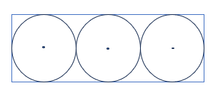
A) 112sq units
B) 132sq units
C) 192sq units
D) 292sq units
Difficulty level: M
Lesson: Circles
- Finish the sequence: $1,3,9,27,81,…$.
A) 243
B) 345
C) 234
D) 199
Difficulty level: L
Lesson: Sequences & Patterns
- If $\frac{x}{y}=4, z-y=6, z=8$, find the sum of $x+y+z$.
A) 12
B) 10
C) 18
D) 16
Difficulty level: L
Lesson: Equations & Inequalities
- Three consecutive numbers, if their sum is equal to the double of the largest number, then the largest number is:
A) 6
B) 3
C) 16
D) 8
Difficulty level: M
Lesson: Sequences & Patterns
- If $|3x|=15$, find the value of $x$.
A) -5
B) +5
C) 6
D) $±5$
Difficulty level: L
Lesson: Equations & Inequalities
- If $x+y=5,z-y=8, and 2z=16$. Find $x+y+z$.
A) 13
B) 15
C) 17
D) 19
Difficulty level: L
Lesson: Equations & Inequalities
- If $2^{30}=2^{a}×2^{b}$, what is the average of $a$ and $b$?
A) 15
B) 24
C) 30
D) 13
Difficulty level: L
Lesson: Exponents
- If $x=2$, find the value of $2x^{3}-x^{2}-8x-1.$
A) -3
B) -5
C) -11
D) -13
Difficulty level: L
Lesson: Equations & Inequalities
- If $\frac{1}{x}+\frac{1}{y}=5, \frac{1}{x}-\frac{1}{y}=2$, find $\frac{1}{x^{2}}-\frac{1}{y^{2}}$.
A) 25
B) 10
C) 20
D) 16
Difficulty level: L
Lesson: Equations & Inequalities

Mock Test 3 - Answer Key

Q# | Answer | Q# | Answer
1 | A | 26 | A
2 | A | 27 | C
3 | B | 28 | C
4 | D | 29 | B
5 | C | 30 | C
6 | A | 31 | D
7 | C | 32 | B
8 | B | 33 | A
9 | C | 34 | A
10 | B | 35 | A
11 | B | 36 | D
12 | A | 37 | C
13 | B | 38 | A
14 | B | 39 | A
15 | B | 40 | B
16 | C | 41 | A
17 | D | 42 | C
18 | C | 43 | A
19 | B | 44 | C
20 | C | 45 | B
21 | C | 46 | D
22 | A | 47 | A
23 | D | 48 | A
24 | A | 49 | B
25 | A | 50 | B

